

Dr. Joseph, Costa inc.

2023-12-24

Dr. Costa

287 Laura Ports, North Lisa, ME 15021

Phone: 8907721316

Fax: 9009738549

**Re:** Anita, Moore

**PHN:** 6684888814

**Birthdate:** 10-Feb-1966

**Address:** 174 Lloyd Trafficway Suite 469, Lake Logan, WI 24320

**Patient number:** 1051852661

To Whom It May Concern:

This is a medical letter to state the above patient is pregnant with expected delivery date of 19-Feb-2025. Hoping this information is satisfactory for your requirements.

Thank you.

Sincerely,

Dr. Joseph, Costa

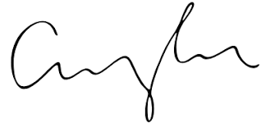

FRCS© NCMP

Clinical Assistant Professor, UBC

Department of Obstetrics and Gynecology SMH